**Experiment 33**

**Lab Book:**

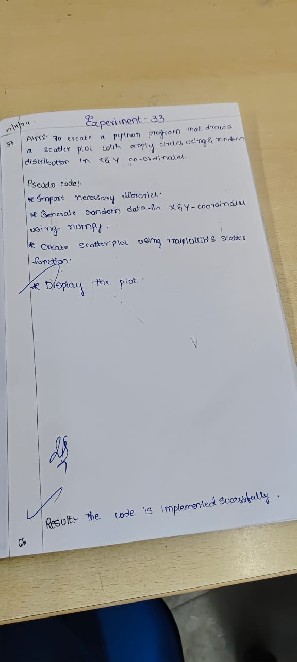

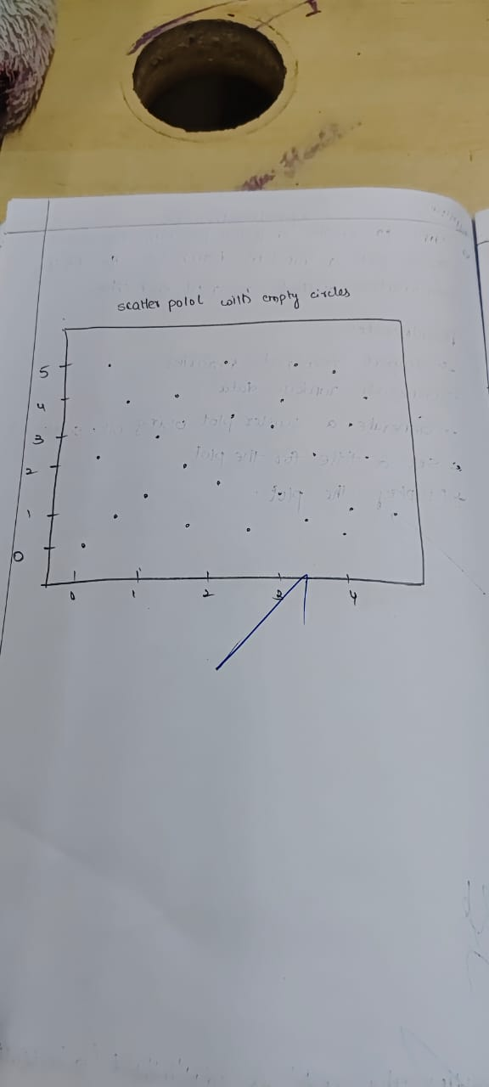

**Code**

import matplotlib.pyplot as plt

import numpy as np

x = np.random.rand(50)

y = np.random.rand(50)

plt.scatter(x, y, facecolors='none', edgecolors='b')

plt.title('Scatter Plot with Empty Circles')

plt.show()

**Sample Output**

